Test Case: tc001_SPX_Dev5_Crear_Requisicion_Spot_Tipo_Cobro_CC
Step 1 - Enter username and password and click to button Enter : Credentials Entered
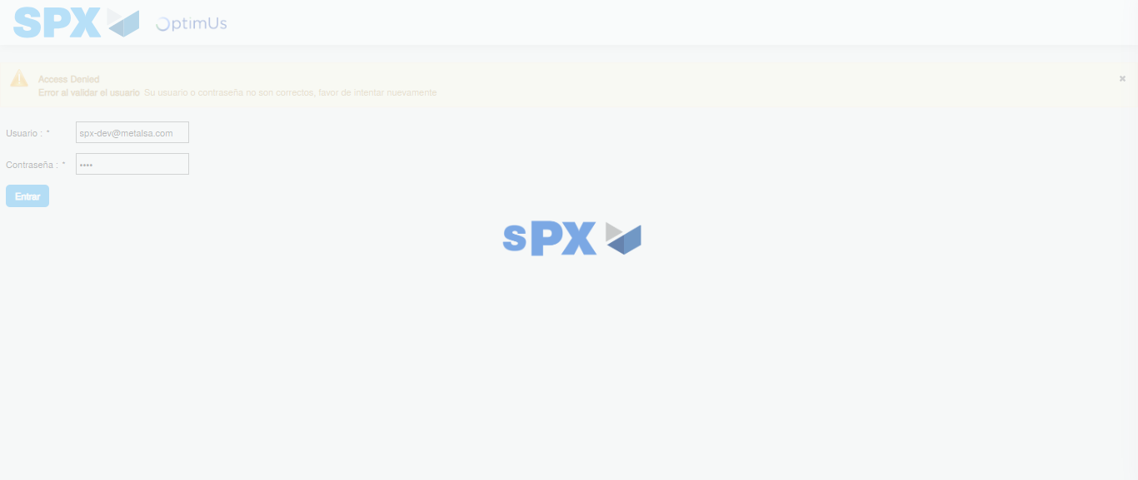Image file-name: QC_Testing-tc001_SPX_Dev5_Crear_Requisicion_Spot_Tipo_Cobro_CC-1782164223232

Step 2 - Select to UEN and Access to Spot Buy Requisitions : UEN Correctly selected and Correct access
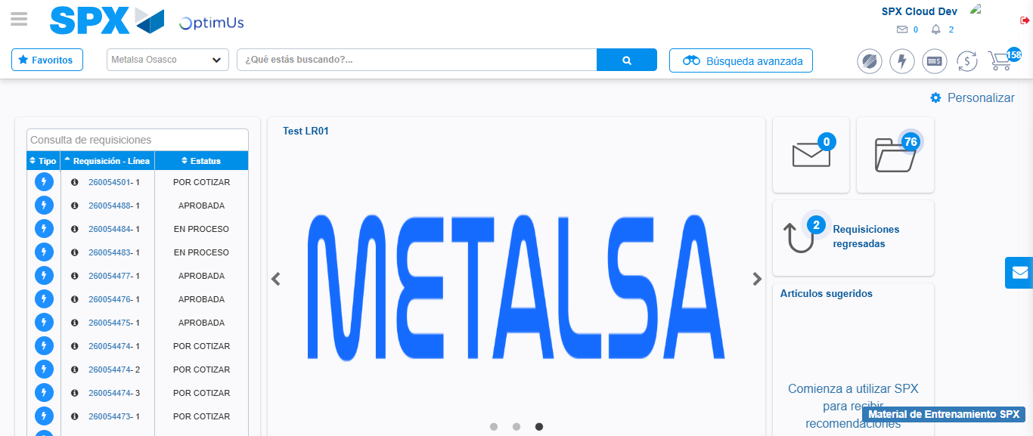Image file-name: QC_Testing-tc001_SPX_Dev5_Crear_Requisicion_Spot_Tipo_Cobro_CC-1782164249644

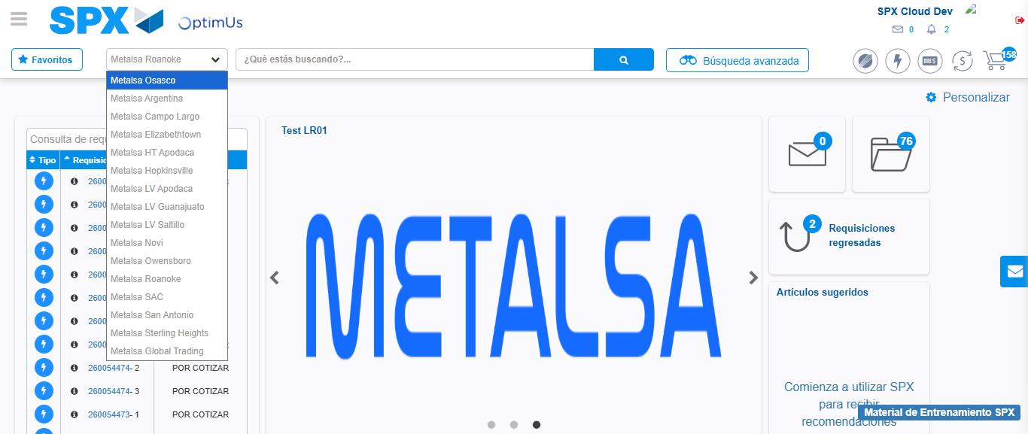Image file-name: QC_Testing-tc001_SPX_Dev5_Crear_Requisicion_Spot_Tipo_Cobro_CC-1782164252189

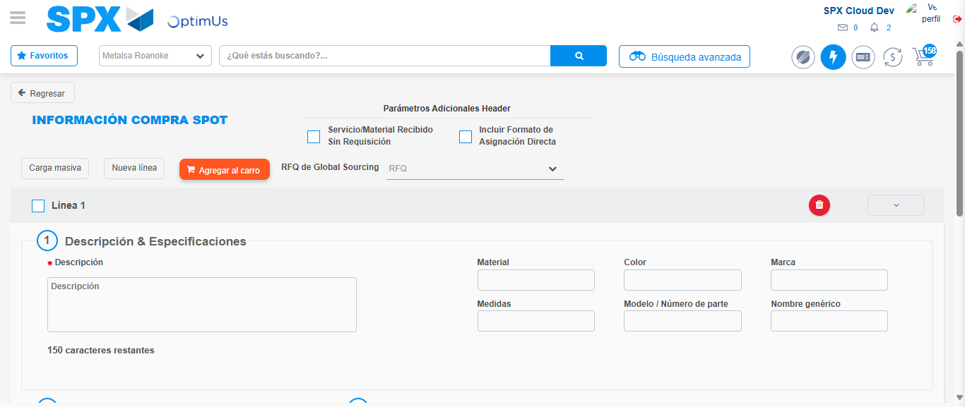Image file-name: QC_Testing-tc001_SPX_Dev5_Crear_Requisicion_Spot_Tipo_Cobro_CC-1782164273943

Step 3 - Data Capture Spot Buy Requisition : Data captured correctly
Image file-name: QC_Testing-tc001_SPX_Dev5_Crear_Requisicion_Spot_Tipo_Cobro_CC-1782164274181

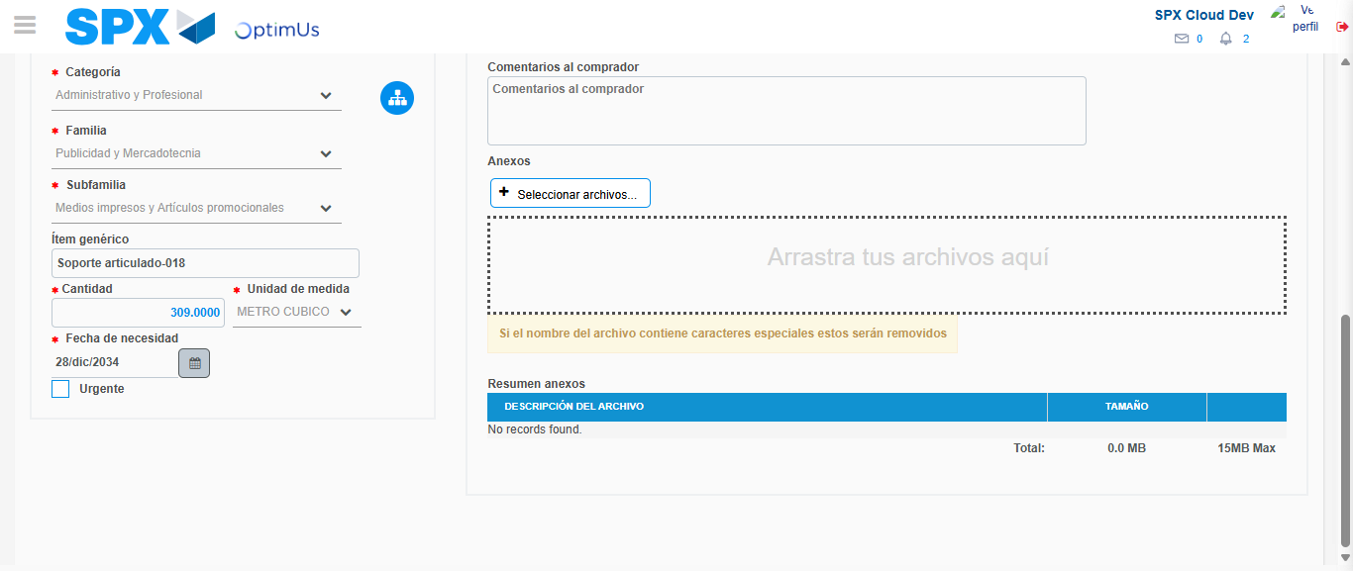Image file-name: QC_Testing-tc001_SPX_Dev5_Crear_Requisicion_Spot_Tipo_Cobro_CC-1782164285508

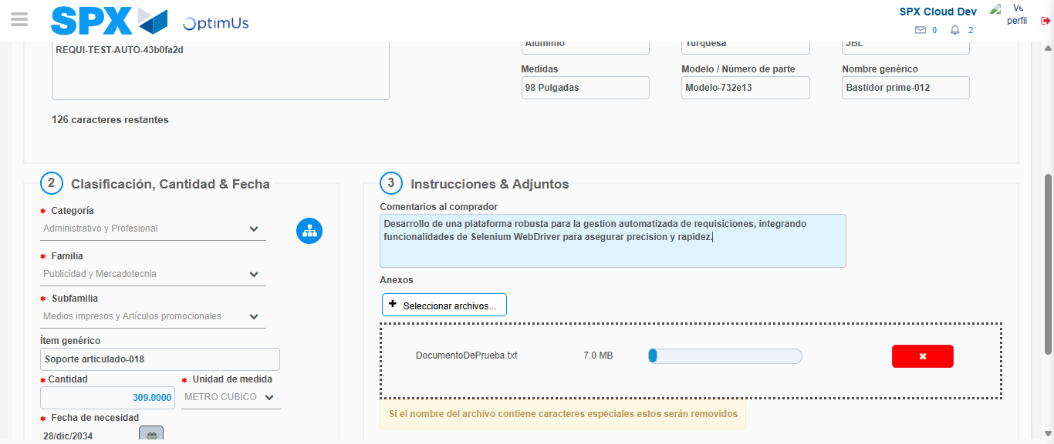Image file-name: QC_Testing-tc001_SPX_Dev5_Crear_Requisicion_Spot_Tipo_Cobro_CC-1782164286328

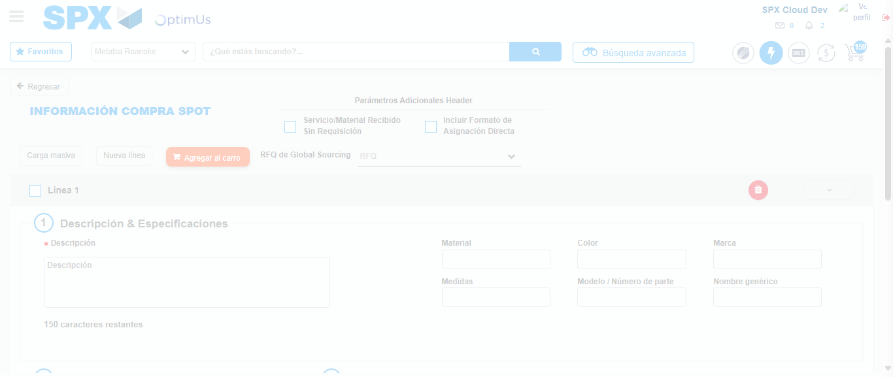Image file-name: QC_Testing-tc001_SPX_Dev5_Crear_Requisicion_Spot_Tipo_Cobro_CC-1782164292929

Step 4 - Select to Requisition : Requisition Correctly selected
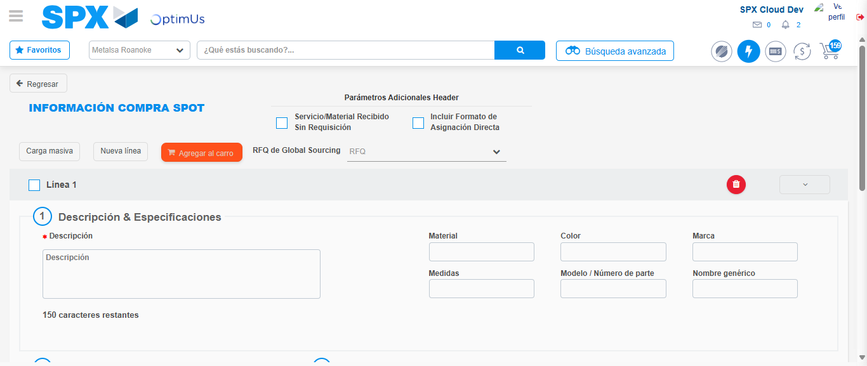Image file-name: QC_Testing-tc001_SPX_Dev5_Crear_Requisicion_Spot_Tipo_Cobro_CC-1782164293138

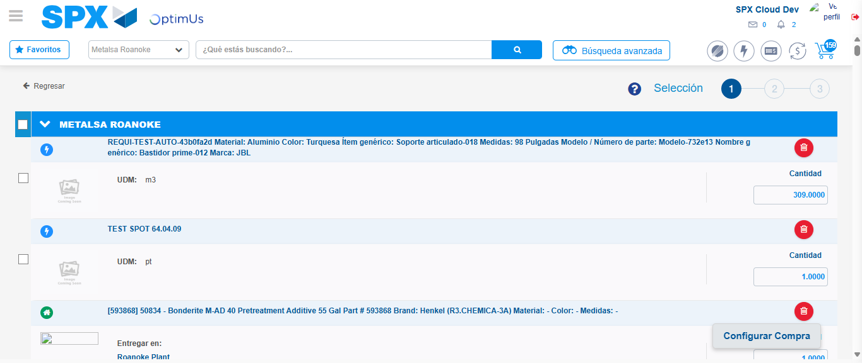Image file-name: QC_Testing-tc001_SPX_Dev5_Crear_Requisicion_Spot_Tipo_Cobro_CC-1782164313953

Image file-name: QC_Testing-tc001_SPX_Dev5_Crear_Requisicion_Spot_Tipo_Cobro_CC-1782164314189

Image file-name: QC_Testing-tc001_SPX_Dev5_Crear_Requisicion_Spot_Tipo_Cobro_CC-1782164314369

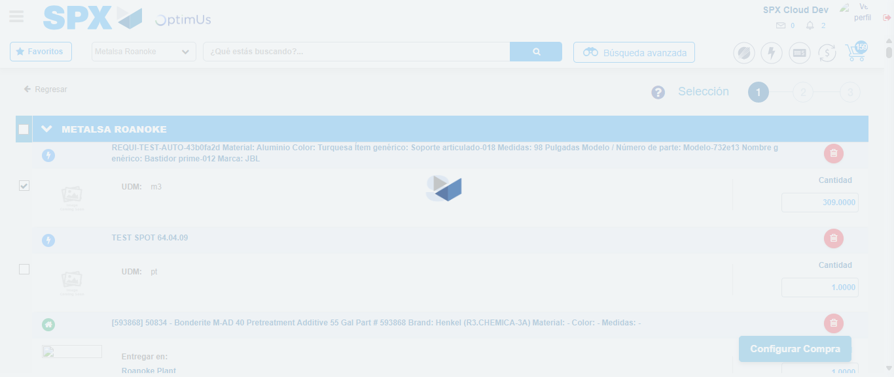Image file-name: QC_Testing-tc001_SPX_Dev5_Crear_Requisicion_Spot_Tipo_Cobro_CC-1782164316287

Step 5 - Select Type Account For Requisition : Type Account Correctly selected
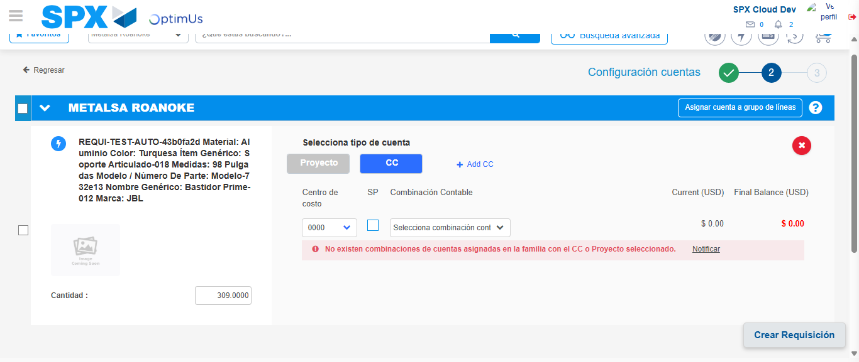Image file-name: QC_Testing-tc001_SPX_Dev5_Crear_Requisicion_Spot_Tipo_Cobro_CC-1782164332592

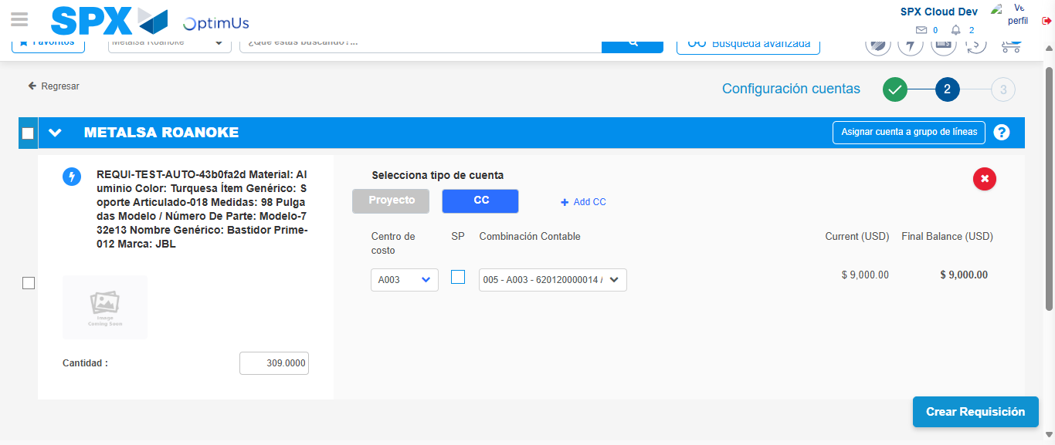Image file-name: QC_Testing-tc001_SPX_Dev5_Crear_Requisicion_Spot_Tipo_Cobro_CC-1782164337991

Image file-name: QC_Testing-tc001_SPX_Dev5_Crear_Requisicion_Spot_Tipo_Cobro_CC-1782164338162

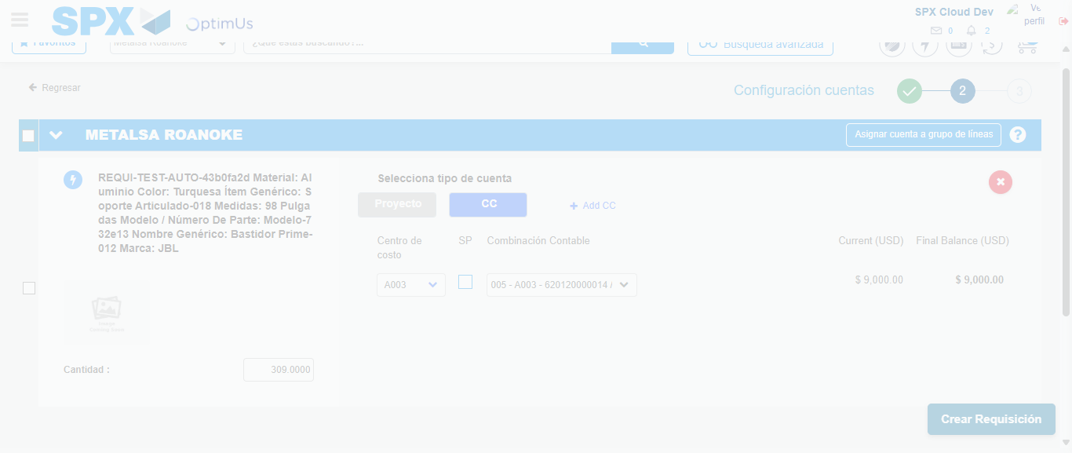Image file-name: QC_Testing-tc001_SPX_Dev5_Crear_Requisicion_Spot_Tipo_Cobro_CC-1782164338537

Step 6 - Accept to Requisition : Requisition Accepted
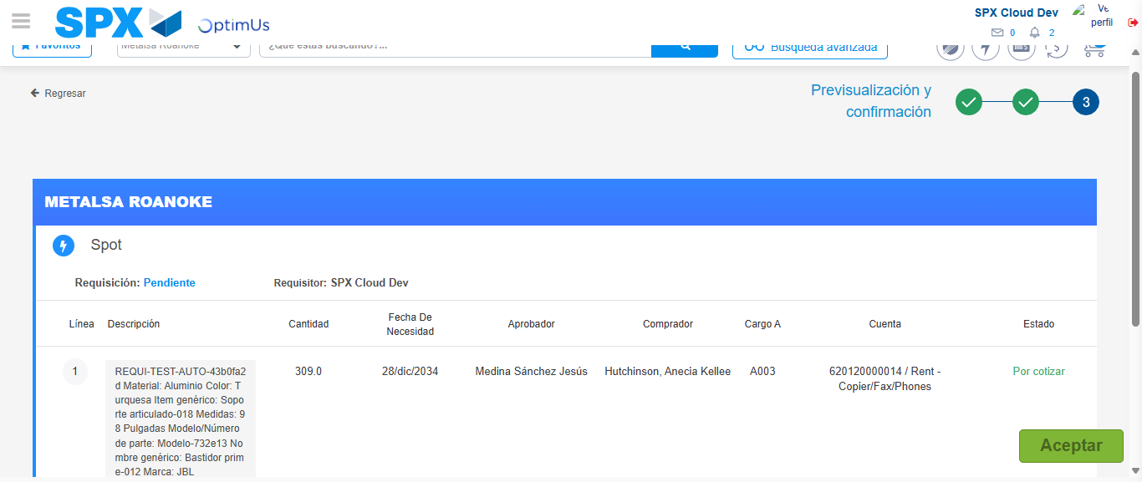Image file-name: QC_Testing-tc001_SPX_Dev5_Crear_Requisicion_Spot_Tipo_Cobro_CC-1782164339834

Image file-name: QC_Testing-tc001_SPX_Dev5_Crear_Requisicion_Spot_Tipo_Cobro_CC-1782164340036

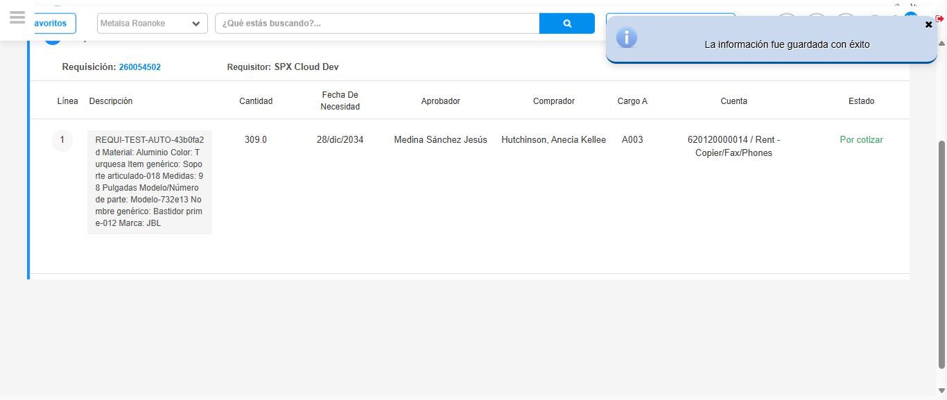Image file-name: QC_Testing-tc001_SPX_Dev5_Crear_Requisicion_Spot_Tipo_Cobro_CC-1782164342995

Step 7 - Return to Main Page SPX : Return to Main Page SPX
Image file-name: QC_Testing-tc001_SPX_Dev5_Crear_Requisicion_Spot_Tipo_Cobro_CC-1782164249644

Image file-name: QC_Testing-tc001_SPX_Dev5_Crear_Requisicion_Spot_Tipo_Cobro_CC-1782164252189

Image file-name: QC_Testing-tc001_SPX_Dev5_Crear_Requisicion_Spot_Tipo_Cobro_CC-1782164273943

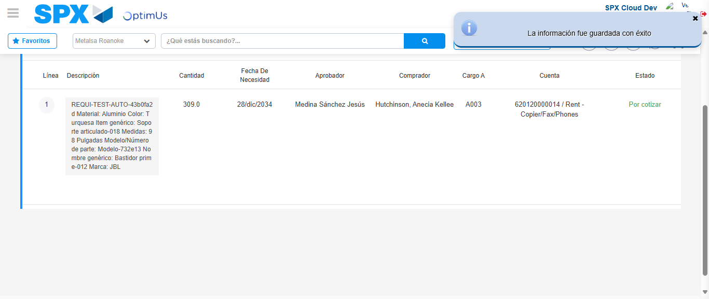Image file-name: QC_Testing-tc001_SPX_Dev5_Crear_Requisicion_Spot_Tipo_Cobro_CC-1782164345220

Image file-name: QC_Testing-tc001_SPX_Dev5_Crear_Requisicion_Spot_Tipo_Cobro_CC-1782164345391

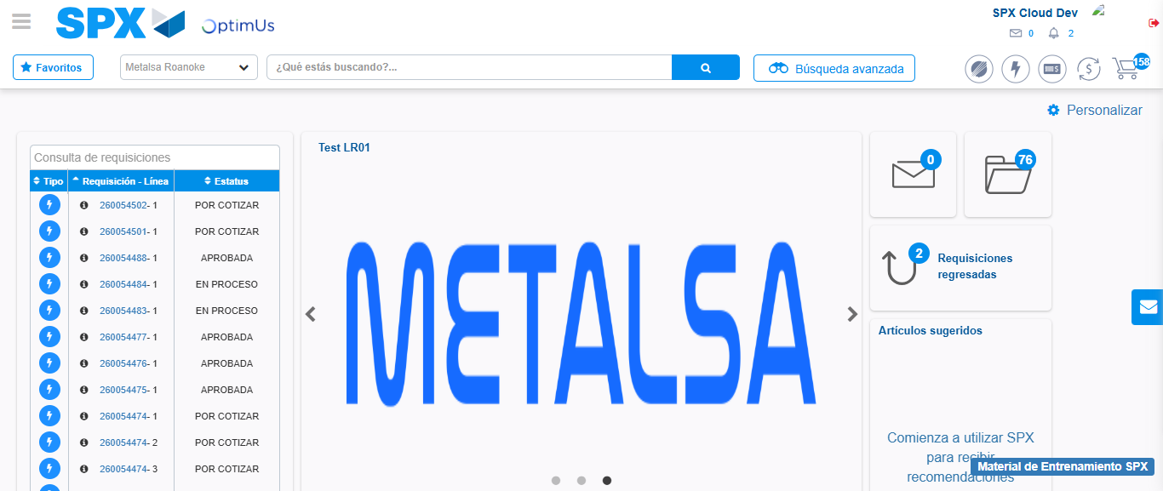Image file-name: QC_Testing-tc001_SPX_Dev5_Crear_Requisicion_Spot_Tipo_Cobro_CC-1782164366424

Step 8 - Log Out : Log Out SPX
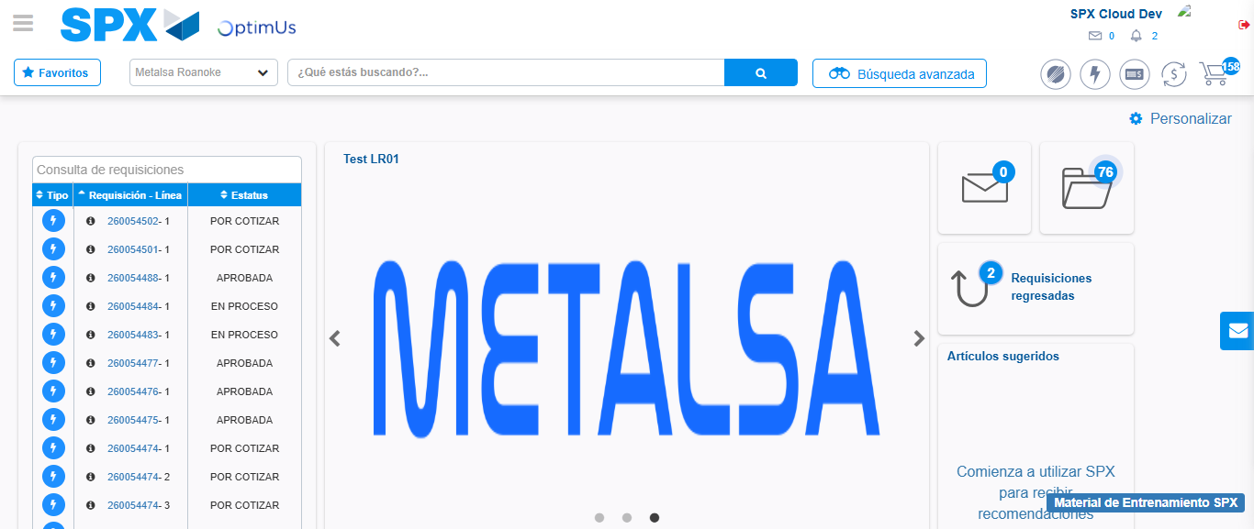Image file-name: QC_Testing-tc001_SPX_Dev5_Crear_Requisicion_Spot_Tipo_Cobro_CC-1782164366714

